Answer Key

Adverb | Original Adjective Form | Adjective Definition
Perfectly | Perfect | B
Fundamentally | Fundamental | A
Deadly | Dead | E
Fatally | Fatal | C
Strangely | Strange | D
Deliriously | Delirious | J
Abundantly | Abundant | F
Strikingly | Striking | G
Incredibly | Incredible | H
Drop-dead | N/A | I (Only functions as an intensifying adverb)
Insanely | Insane | L
Hugely | Huge | K

Suggested collocations:
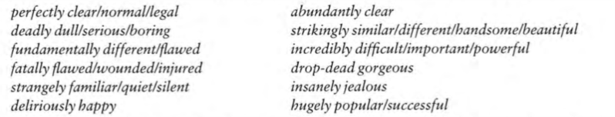

Adverbs like "fundamentally," "strikingly," and "abundantly" have retained most of their original meanings, whereas "fatally," "perfectly," "deadly," and others have lost much of their original meaning due to their metaphorical or exaggerated use in these collocations.

